**MileOne x MovableInk Projects**

[**Behavioral Pods**](https://app.movableink.com/studio/3459650)

App build started May 2020

* Behavioral logic based on appended facets in the URL string. [Spreadsheet example.](https://docs.google.com/spreadsheets/d/1x_Ff1zOKwvJtIcKTazkByqI3XyFI4WV4vGu067KyDxk/edit#gid=0)
* Logic built in to calculate Savings (MSRP – Final Price/Internet Price = Savings).
* Script to hide savings section if not available.
* Fallback if Behavioral not available is Item index# inventory (not working correctly).
* Mi_test_u (What is this? Seems to be part of the app structure – example below).  
    
  let mi_u = app.getProperty('mi_u');  
  let mi_test_u = app.getProperty('mi_test_u');  
  const url = `https://sorcerer.movableink-templates.com/data_sources/f58a600d5a6cba2e?mi_u=${mi_test_u}`
* Several versions of this app remain on the MI backend. Can the old & broken versions be removed?

----  
Desired outcome was outlined during feasibility testing, however first app version sent to MileOne was missing functionality. MileOne team provided solutions for MovableInk to implement.

Several versions of the app have been created by MI to try and resolve issues over the last few months. Fallback issue still persists.

[**Automation Inventory Pods**](https://app.movableink.com/studio/3437481)

App build started February 2021

* 3Birds built a custom API to integrate into MovableInk
* Original feasibility tests performed using **client code and model name** merge fields from ESP.
* App logic was outlined after feasibility tests, however the finished app has a   
  make token (mi_make), not model.  
    
  This works for pre-owned, however for new vehicles the **client code** dictates the dealership and brand, therefore vehicle model is needed. Example:  
    
  mi_client_code = 173033 (Hall Hyundai Newport News)  
  New make = Hyundai  
    
  **A token for model (mi_model) should be added because the entire campaign personalization works based on the model name.** [Video Example.](https://images.mileone.com/Peter/2021/4/Vehicle-Count-API-Test.mov)  
  If possible mi_model and mi_make would work separate from each other so we can use them for new and pre-owned vehicles respectively.

**Web Personalization Issues**

Last month we personalized the link and first name on our landing page coupons. [Campaign Link](https://app.movableink.com/cp/5404c00085b14c4c?company_channel_id=30823)

* Web CSV link personalization was not working in Preview pane or on landing page. MI tested and send to solutions team.
* MileOne team switched campaigns to Targets instead of Data Source personalization so we could meet deadlines.
* Resolution provided by MI team was that the CSV function started working, however after testing further I can’t get the same outcome consistently.

**Outdated Apps in App Gallery**

* Custom apps discussed above and others are outdated in our App gallery. Once they are finalized, can they be updated here? We requested this before but no solution was provided.
* Currently we have to copy campaigns containing the latest app.

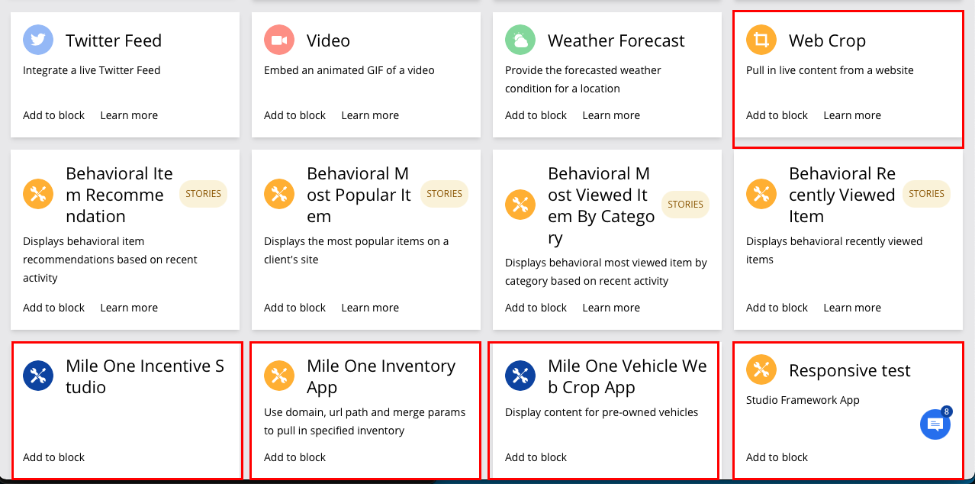

**mi_u Encoding Issue for Automation Groups**

* MileOne team requested a fix, which MovableInk team implemented.
* Issue persisted. MileOne resolved issue.